**Rockler CNC Demonstration 2019-4 (#16)**

April 6, 2019

**Molding toolpath for chair seat, importing a STL 3D file (TJ)**

**Fluting toolpath for chair seat (Kenneth)**

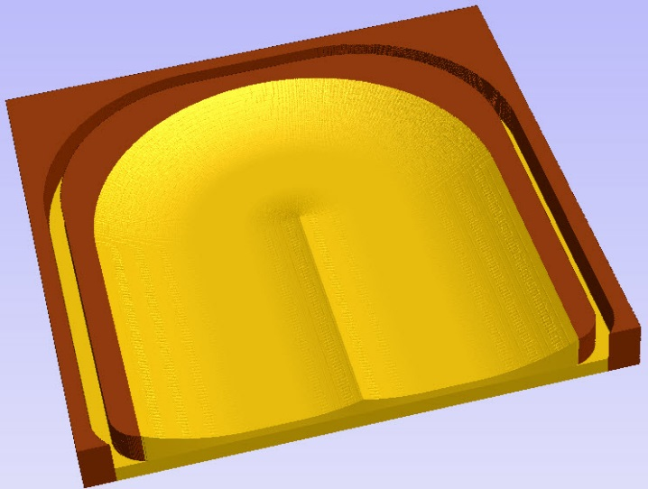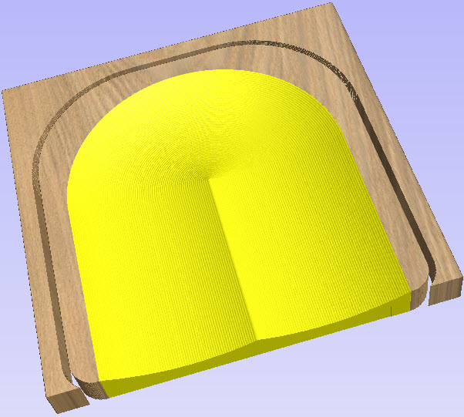

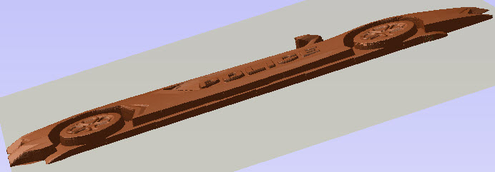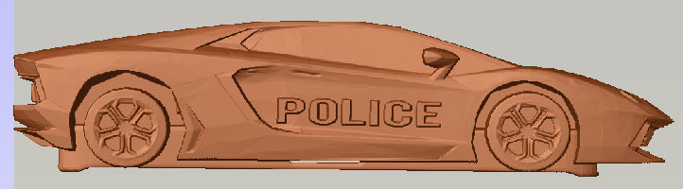

**Tools used in this Demo -** ¼” Ball Nose and EM

**Create Design**

1. Drawing tab: Start new file - Fill out job set up
   1. Single sided
   2. 16 W x 16H x 1.5 Thick
   3. Choose data point preferences
      1. For layout only we will use the center datum position
   4. Click OK
2. Drawing tab: Draw Rectangle
   1. Anchor lower left at x=0, y=.5
   2. Radius corners with 1” radius
   3. Enter 14” W x 15” H
3. Drawing tab: Select Fillets
   1. Enter 5” radius
   2. Click on lower left and right to change radius to 5”
4. Drawing tab: Draw Circle
   1. Enter 12” radius
   2. Click Create
5. Drawing tab: Draw Line
   1. Make 2 lines, one on each side of the circle to the top of the seat, use space bar between lines
   2. Right Click to end line
6. Drawing tab: Use Scissors to remove the top half of the circle
7. Drawing tab: Draw Rectangle for construction purposes
   1. Anchor upper left at x=-6, y=8
   2. Enter 5.985” W x 0.75” H
8. Drawing tab: Draw Arc through 3 points
   1. 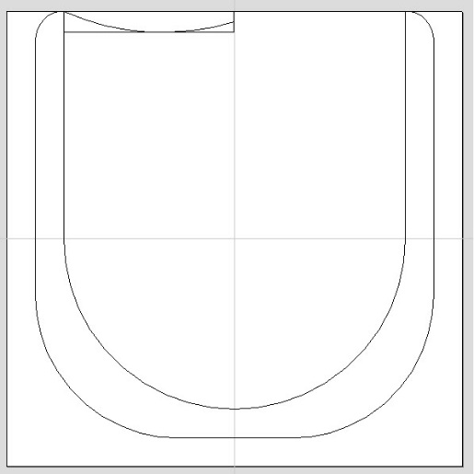Start at upper left of construction box
   2. End at the mid point of the right side of the construction box
   3. Draw center of the arc down to the bottom of the construction box
   4. Click Create
9. You should have something like the picture to the right and now are now ready to make TOOL PATHS

**Create TOOL PATHS**

1. Set properties
   1. Tool clearance to 1”
   2. Set datum to lower left (from the center that we used for layout)
2. Use “Molding” tool path
   1. Select the 3 lines for the Drive Rail, half circle and both lines
   2. 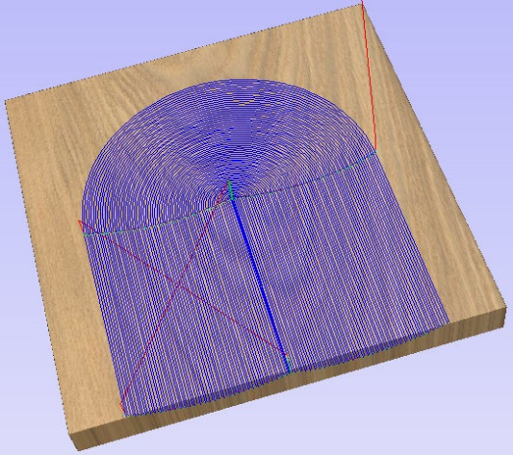Select only the arc drawn in the construction box
   3. Make sure the carve lines are correct or right click on a drive rail and click “Reverse Direction”
   4. Select 1/4” Ball Nose and enter depths and speeds for your machine
      1. Use 30% step over
   5. Calculate toolpath
   6. Preview toolpath
3. Use the “Profile” tool path
   1. Select outside seat shape
   2. Enter
      1. 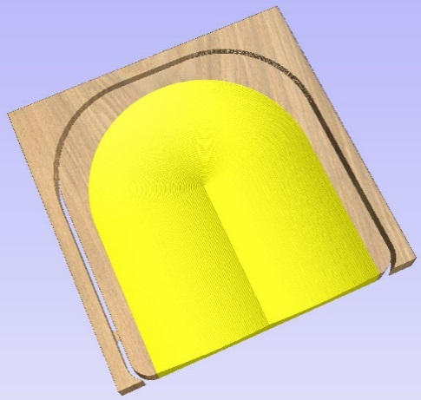Set start depth to 0”
      2. Set cut depth to 1.55” too cut all the way through
      3. Select 1/4” End Mill and enter depths and speeds for your machine
      4. Check “Outside”
      5. Add tabs
         1. 0.5” long x 0.25” thick
         2. Evenly locate them around the seat
      6. Click Calculate
      7. Preview toolpath
4. Save above Tool Paths to USB drive
   1. Add tool description to file name, for pendant machines make first 5 characters meaningful
   2. Save ENTIRE project file
5. DONE – ready to cut

**Set up wood to be cut**

1. Make sure properly secured
2. Run file for Swept file
3. Run file for Profile

**Part 2 – importing a .STL file**

**Start new job** (or add to one already created)

1. Drawing tab: Start new file - Fill out job set up
   1. Single sided
   2. 12 W x 12H x 0.75 Thick
   3. Choose data point preferences
   4. Click OK
2. 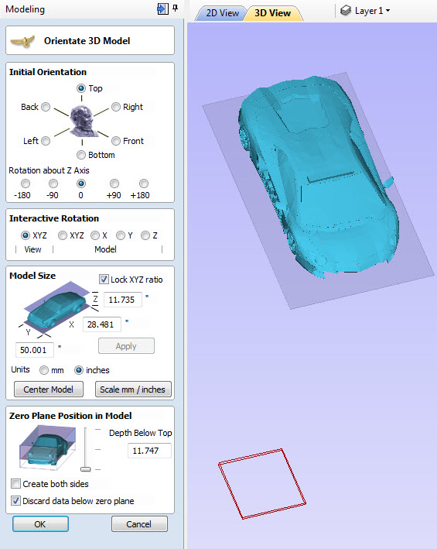Modeling tab: Click “import a 3D component or 3D model”
3. Choose your STL file from your computer
4. This menu (to right) will pop up with your 3D solid model
5. Entire model is displayed with ZERO plane and work piece however there is no know size or units.
6. Set Model Size
   1. Click “Scale mm/inches”
   2. With XYZ locked, change X to 8”
   3. Click Center Model
7. Change View to X
8. Change “Interactive Rotation” to Model X
9. Rotate up 90 degrees to see bottom of car
10. Go back to View XYZ
11. Position Zero plane up closer to side of car
12. Click “OK”
13. You now have a component but it needs to be trimmed down
14. Modeling Tab: Scale model height to 0.5”
15. Done, This can now be cut or added to your job design just like any other clip art.

**Question?**

**Ideas for next Demo…**