**Rockler CNC Demonstration #14**

February 2, 2019

**Text on 3D Component Surfaces**

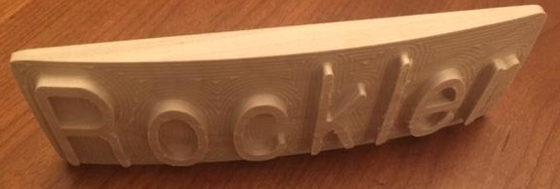

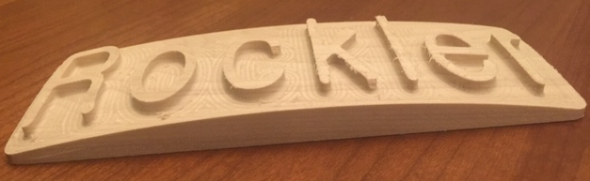

**Tools used in this Demo -** 1/8” and ¼” Ball Nose

**Create Design**

1. Start new file - Fill out job set up
   1. Single sided
   2. 11 W x 3.5H x 0.75 Thick
   3. Choose data point preferences
   4. Click OK
2. Go to Clip Art Tab
   1. Go to “Domes” folder
   2. Select “Dish_Dome_30”, double click will center it
   3. Go to “3D Tabs” folder
   4. Select “Rectangular_0.5”, double click will center it
   5. Select “Rectangular_0.25” and drag one to line up with left of the work piece
3. Go to drawing tab to resize all 3D Objects
   1. Select the Dome
   2. Select “Set Selected Object Size”
   3. Enter 9” in either width or height and check box to link XY
   4. Click Apply and Close
   5. Select the Rectangular 0.5” Object
   6. Select “Set Selected Object Size”
   7. Enter 8” W x 3” H
   8. Click Apply and Close
   9. Select the Rectangular 0.25 Object
   10. Select “Set Selected Object Size”
   11. Enter 1” W x 0.75” H
   12. Click Apply and Close
4. Adjust height and relationship between all 3D Objects
   1. Go to Modeling Tab
   2. Select the Dome by double clicking to bring up the properties box
   3. Change Height to 0.5”
   4. Change Base Height to 1/16”
   5. Check “Add”
   6. Click Close
   7. Select the Rectangular Object by double clicking to bring up the properties box
   8. Change Height to 3/16”
   9. Check “Add”
   10. Click Close
   11. Locate first 3D tab, got to properties and change to 3/8” thick, locate on left side then copy to the right side
5. Create Text Box
   1. Go to Modeling Tab
   2. Select Rectangular _0.5
   3. In 3D Model Tools, select “Create Vector Boundary”
   4. Go to Drawing Tab
   5. Select the boundary box created in step above
   6. Select “Draw Text in Vector Box”
   7. Enter “Rockler”
   8. Chose Text “Gulim”
   9. Check Bold
   10. Check Normal Margin
   11. Vertical stretch set to “Stretch Characters”
   12. Click “Close”
   13. Select “Edit text spacing” and add spaces between letters to allow for an 1/4” EM tool
   14. **IMPORTANT** Select Box and create an offset of 1/8”, delete original, TJ to explain this

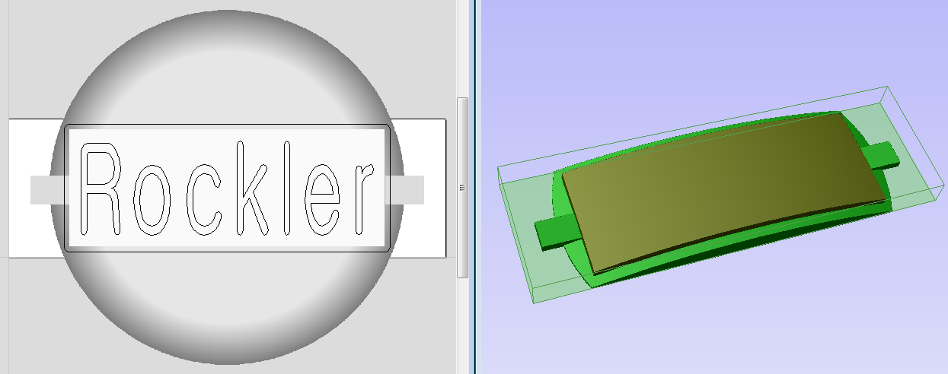

1. You should have something like the above picture and are now ready to make TOOL PATHS

**Create TOOL PATHS**

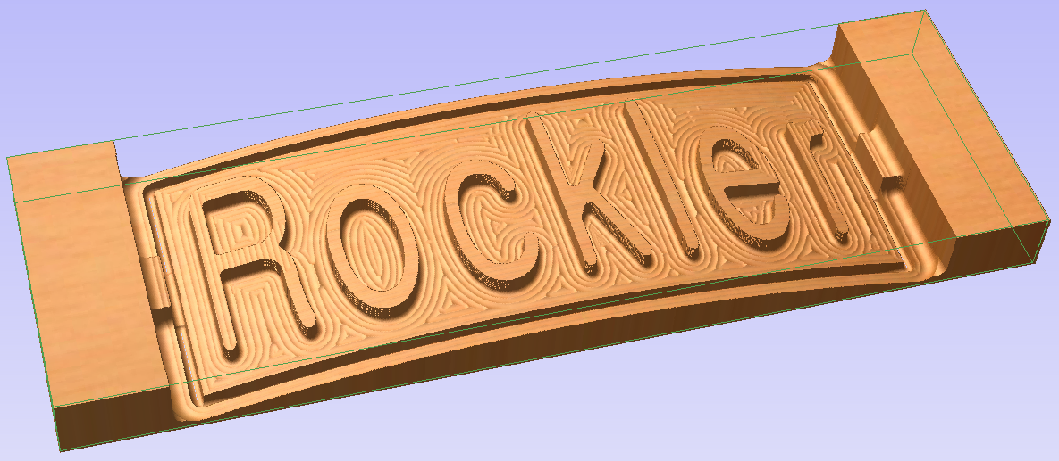

1. 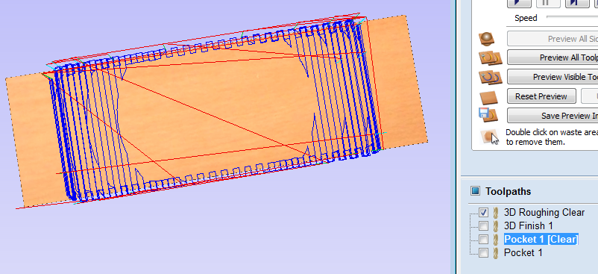Set properties
   1. Tool clearance to 1”
   2. Set datum to lower left
2. Use 3D Roughing tool path
   1. Select the border box
   2. Select 3D Roughing tool path
      1. Select 1/4” Ball Nose and enter depths and speeds for your machine
      2. Check “Selected Vectors”
      3. Enter a boundary offset of 0.25”
      4. Enter a machine allowance of 1/32”
      5. Select Z Level, Raster X, Profile None
      6. Change Name to Roughing Clear
      7. Click Calculate
3. Use 3D Finishing tool path
   1. Select the border box
   2. Select 3D Finishing tool path
      1. 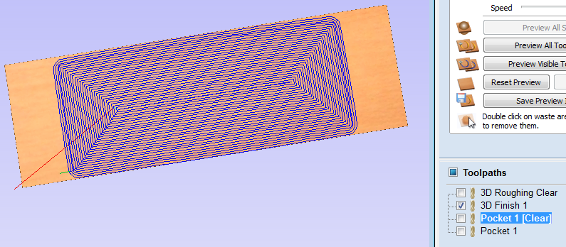Select 1/4” Ball Nose and enter depths and speeds for your machine (to make a nice smooth finish on the top of the letters, either use a small step over number or sand smooth when done)
      2. Check “Selected Vectors”
      3. Enter a boundary offset of 0.125”
      4. Select Offset Conventional
      5. Change Name to Finish Surface
      6. Click Calculate
4. 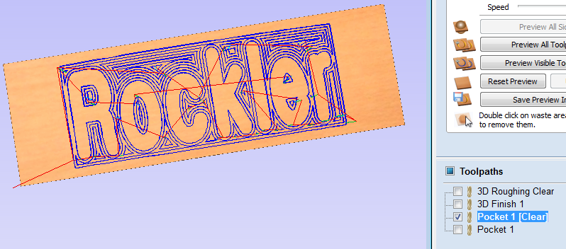Use the “Pocket” tool path
   1. Select both the text and border box
   2. Select Pocket tool path
      1. Set start depth to 0”
      2. Set cut depth to 3/16”
      3. Check “show advanced toolpath options”
      4. Select 1/8” Ball Nose and enter depths and speeds for your machine
      5. Check “Use Larger Area Clearance Tool”
      6. Select 1/4” Ball Nose and enter depth and speeds for your machine
      7. Select offset / conventional
      8. **VERY IMPORTANT** Click box for “Project toolpath onto 3D model”
      9. Change name to Pocket Text
      10. Click Calculate
   3. You will notice 2 toolpaths were made, one for each tool size
5. 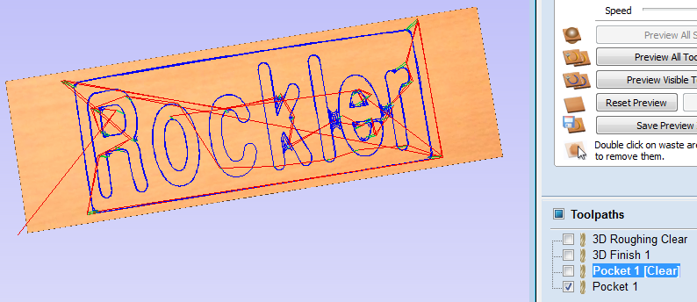Save above Tool Paths to USB drive
   1. Add tool description to file name, for pendant machines make first 5 characters meaningful
   2. Save ENTIRE project file
6. DONE – ready to cut

**Set up wood to be cut**

1. Make sure properly secured
2. JOG create 0,0,0
3. Run file for 3D Rough (pre run before Demo)
4. Run file for 3D Finish (pre run before Demo)
5. Run file for Text Pocket Clear
6. Run file for Text Pocket

**Question?**

**Ideas for next Demo…**