**Rockler CNC Demonstration #2 - Spoil Boards for CNC Shark**

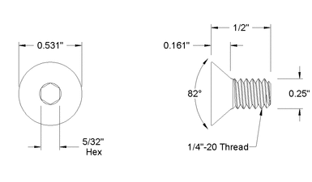January 6, 2018

**Material List:** 24” x 48” x ¾” sheet MDF

36 – ¼ ” x 20 x ½” flat head machine screws

36 - ¼ ” x 20 oval nuts

**Tool List:** ¼” end mill up spiral

½” standard countersink bit

1 ½” diameter Freud TM1465

**Prep work:** Cut MDF in to 3 – 16” x 24” pieces

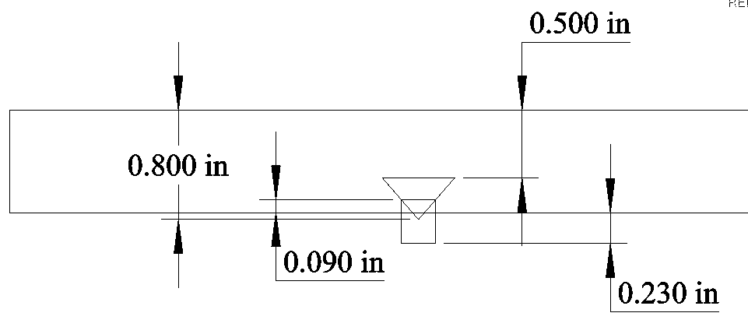**In VCarve : Create Design**

1. **Start new file**
   1. 24” x 16” x 0.75”
   2. Discuss Z Zero and XY Datum
2. **“DRAW RECTANGLE”** 
   1. Anchor lower left, X=0.5, Y=1.5
   2. Radius corners, 1/8”
   3. Set W=2.625 H=13, Create
   4. Next create temporary rectangles to help locate holes
   5. Leave anchor point same
   6. Change to square corners
   7. W=13/16, Y=3, CREATE
   8. Repeat for top right corner
3. **“DRAW CIRCLE”**
   1. Draw 3 circles at the inside corner of each temporary rectangle
   2. One with each of these D=0.6, D=0.5, D=0.25
   3. Delete both rectangles

**Note:** For today’s Demo we premade 16 of the 18 required spoil boards to save time and minimize the amount of noise created while cutting the MDF parts. We will just run the last 2 spoil boards to allow us to install all 18 needed to complete this project.

1. **“ARRAY COPY”**
   1. Select all then select Array Copy
   2. Rows=1, Columns=8 (see Note)
   3. Gap = ¼” plus 1/32”
   4. Click Copy
2. **DONE ready to make TOOL PATHS**

**In VCarve : Create TOOL PATHS**

1. **Set properties**
   1. Datum to lower left
2. **“Pocket Tool” path for 0.6”D circle**
   1. Select all 0.6”D circles
   2. Select pocket toolpath
      1. Cut depth 0.5
      2. Select ¼” EM, Edit with pass depth 5/32, Feed rate 75
      3. Name as Clearance Hole and calculate
3. **“Drill Toolpath” for 0.25”D circle**
   1. Select all 0.25”D circles
   2. Select Drilling Toolpath
      1. Cut depth 0.78
      2. Select ¼” EM
      3. Name as Drill Hole and calculate
4. **“Profile Toolpath” for all 8 spoil boards**
   1. Select all 8 board profiles
   2. Select Profile Toolpath
      1. Cut depth 0.78
      2. Select ¼” EM, Edit with pass depth 5/32, Feed rate 60
      3. Add tabs ½ x 1/8 thick
      4. Name as Profile 8 boards and calculate
5. **Save all 3 toolpaths above to one file on USB**
   1. Add tool description to file name
6. **“Drill Toolpath” for 0.5”D circle**
   1. Select all 0.5”D circles
   2. Select Drilling Toolpath
      1. Cut depth 0.8
      2. Select ½” 90 degree V bit
      3. Name as Countersink Hole and calculate
7. **Save above Tool Path to USB**
   1. Add tool description to file name
8. **Save ENTIRE project file**

**Set up wood to be cut**

1. Make sure properly secured - show broken bit and hold down clamps
2. JOG create 0,0,0
   1. Demonstrate Z set up
3. 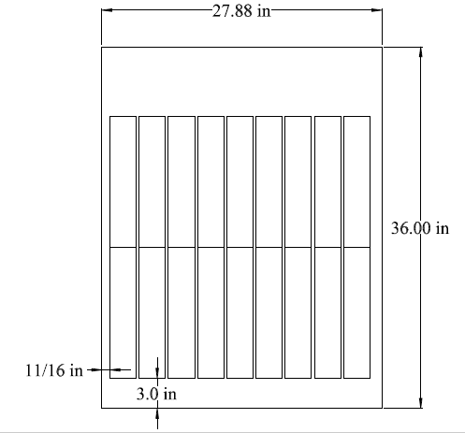Run file for ¼ End Mill
4. Run file for Counter sink bit

**Assemble spoil boards and tighten hardware**

Next we will create tool paths to resurface the spoil board to assure they are flat and then remove radius corners and excess material in the X+ and Y+ direction.

**In VCarve :**

1. **Start new file**
   1. 24” x 24” x 0.75”
2. **“DRAW RECTANGLE”** 
   1. Anchor lower left, X=0, Y=0
   2. Square corners
   3. Set W=24 H=24, Create
3. **“DRAW POLYLINE”** 
   1. Top left to top right to bottom right, end
   2. Lower left up 45 degrees for ½”
4. **“MIRROR COPY”**
   1. Select lower left polyline
   2. Select Mirror Copy
      1. Click square Flip about center
      2. Click square Create a mirrored copy
      3. Click Flip Vertical
      4. Reselect lower and upper left polyline
      5. Click Flip Horizontal
      6. Close mirror copy

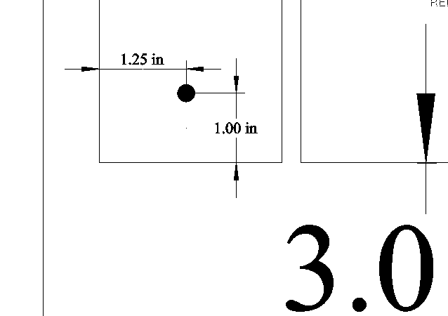**In VCarve : Create TOOL PATHS**

1. **Set properties**
   1. Datum to lower left
   2. When running this toolpath, set 0,0 to dimensions shown at right.

**Caution! You must first confirm that using these dimensions will not cause over travel of CNC carriage.**

1. **“Pocket Tool”** 
   1. Select 24 x 24 Rectangle
   2. Select pocket toolpath
      1. Cut depth 1/64”
      2. Select 1-1/2” EM, Feed rate 100
         1. If tool not in DB, copy and create
      3. Name as Resurface and calculate
2. **“Profile Toolpath”** 
   1. Select Polyline that goes from top left to bottom right
   2. Select Profile Toolpath
      1. Cut depth 1/64
      2. Select 1-1/2” EM, Feed rate 100
      3. Click on
      4. Name as Top and Right, calculate
3. **“Profile Toolpath”** 
   1. Select all 4 small Polylines in the corners
   2. Select Profile Toolpath
      1. Cut depth 1/64
      2. Select 1-1/2” EM, Feed rate 100
      3. Click on
      4. Name as Clear Corners, calculate
4. **Save all 3 toolpaths above to one file on USB**
   1. Add tool description 1-1-5EM to file name
   2. Run this file

**QUESTIONS?**

Front View Back View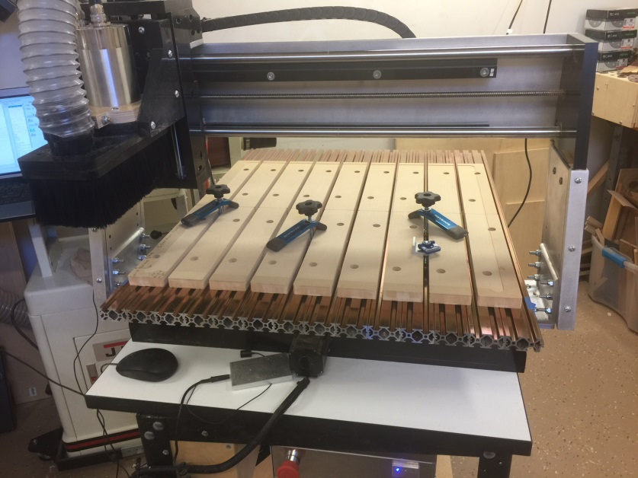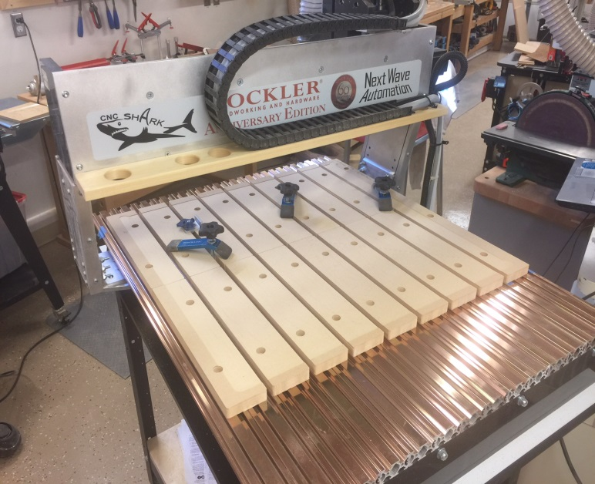

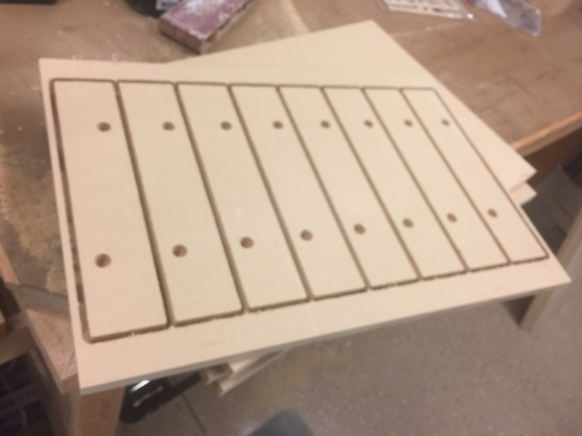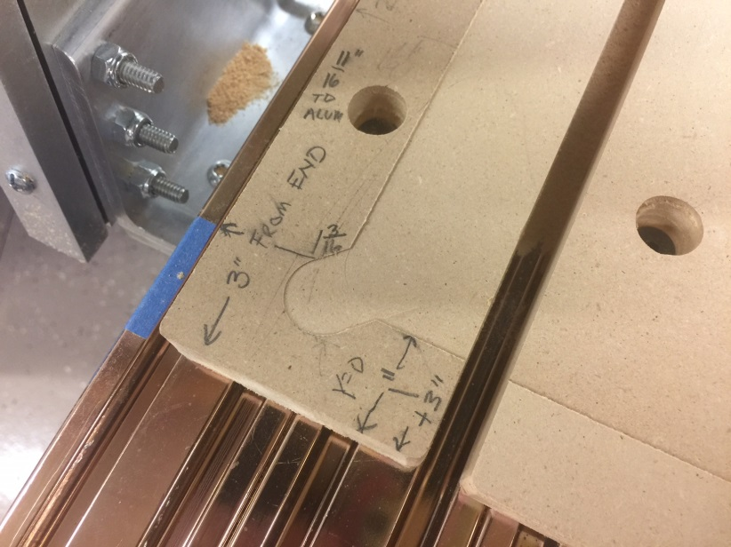

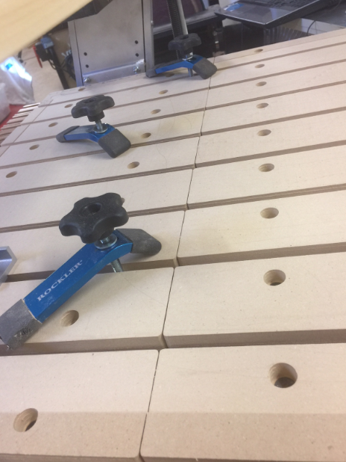Corner Cutout 8 Spoil boards on 16 x 24 MDF

There will be a seam down the middle with 2 rows of 9